

MASENO UNIVERSITY
SCHOOL OF COMPUTING AND INFORMATICS
DEPARTMENT OF INFORMATION TECHNOLOGY

HELP-KAZI ONLINE JOB APPLICATION SYSTEM

CIT 208: GROUP PROJECT

PROJECT PROPOSAL SUBMITTED TO THE SCHOOL OF COMPUTING AND INFORMATICS IN PARTIAL FULFILMENT OF THE REQUIREMENTS FOR AWARD OF THE DEGREE OF BACHELOR OF SCIENCE IN INFORMATION TECHNOLOGY

OCTOBER, 2021
MASENO UNIVERSITY
P.O. BOX PRIVATE BAG
MASENO, KENYA

DECLARATION
We certify that this project proposal is our original work and all material herein which is not our own work has been identified. We further certify that no material herein has previously been submitted and approved for the award of any degree, or any other award, by this or any other university.
ADM NO. | NAMES | SIGNATURE
CIT/00124/019 | MARITA DIANA
CIT/00088/019 | NATHAN MUTAI
CIT/00111/019 | STEPHEN MWAU
CIT/00052/019 | KEYA VICTOR WABUTI
CIT/00029/019 | MALABA BRIAN SIKENYI

This project proposal has been submitted for examination with my approval as the university supervisor.

--------------------------------------------------- ------------------------------------
James Chamwama Date
Maseno University
ABSTRACT
In recent years, there has been a sudden growth in population. This has led to an increase in job applications and a sudden rise in demand for manpower for both skilled and non-skilled. Therefore, there is a need to develop a system that can allow job seekers to secure jobs and also assist employers to locate potential candidates for their organizational roles. In a country, with a high population of 48million, people need a stable and well-paying job to provide for their families and also boost the economy of the country. Potential and skilled job seekers do have a rough time in locating the right job for them to put their skills into action. For some, they have to move from one organization to another in search of a relevant job. This process can be quite costly and time-consuming. Nevertheless, an organization that needs a certain number of employees to fill up any organizational vacancies, they have to incur additional cost for advertising the job vacancies to the mass. These costs include media costs such as TV advertisements, radio advertisements, and billboards which we all know can be quite expensive for an organization and a less efficient method of advertising the job application vacancies. Therefore, this is a gap that needs to be filled.

The Help-Kazi platform is a web-based application that allows job seekers to find and apply for any open job application vacancies. It also assists an organization to post available job vacancies and find the required and potential clients (employees).
If the system is fully adopted, the country's economy will grow, families will be well provided for and also the living standards will be improved.

ACKNOWLEDGEMENT
We wish to thank the Almighty God for guiding us to come up with the idea of developing a library system that will enhance the utilization of library resources online. We also thank our lecturers of Maseno University for equipping us with the knowledge capabilities that led us towards the idea of online job application system. More specifically, we would to acknowledge our supervisor, Mr. Chamwama for the invaluable guidance and support throughout the course of our project.

Table of Contents
DECLARATION i
ABSTRACT ii
ACKNOWLEDGEMENT iii
CHAPTER 1 INTRODUCTION 1
1.1 Background to the Study 2
1.2 Problem Statement 2
1.3 Main objective 2
1.4 Specific Objectives 3
1.5 Justification of the Project 3
1.6 Limitations 3
1.7 Project Schedule 4
CHAPTER 2 LITERATURE REVIEW 5
2.1 Introduction 5
2.2 The Scope of Review 5
2.3 Criteria Used 6
2.4 Historical Background 6
2.6 Previous Studies 7
2.8 Conclusions 8
CHAPTER 3 RESEARCH METHODOLOGY 9
3.1 Introduction 9
3.2 Summary of the Research Process 9
3.3 Research Design 10
3.4 System Requirement Gathering and Analysis 11
3.4.1 Requirement Gathering: Data Collection 11
Questionnaires 11
3.5 User Requirements Modelling 13
3.5.1 Use Case Modelling 13
CHAPTER 4: SYSTEM DEVELOPMENT AND IMPLEMENTATION 17
4.1 Development Environment: Hardware Components 17
4.2 Development Environment: Software Components 17
4.3 System Testing and Evaluation 18
4.4 Unit Testing 19
4.5 Integration Testing 19
4.6 System Testing 20
4.7 User Testing 20
CHAPTER 5: CONCLUSION 21
5.1 Shortcomings of the System 21
5.2 Recommendation for Future Work 22
REFERENCES 23
APPENDIX 1: 25
APPENDIX 2: 26

LIST OF FIGURES AND TABLES

Figure 1: Project Schedule 4
Figure 2 Use case diagram. 13
Figure 3. Client’s activity diagram. 14
Figure 4.Employer’s activity diagram 15
Figure 5.Help-Kazi database design 16

CHAPTER 1 INTRODUCTION
Whether entering the job market for the first time or re-entering after a break or switching career, job search is a challenging task. But how about tools/applications, making this tedious process look friendly, systematic and easy to reach out, to employers or candidates? Searching and landing up with a dream job is a tedious process for a job seeker and on the opposite hand, connecting with desirable candidates best fit for a job position is a challenging and important work for the employers. This project is aimed at making such challenges much easier despite the geographic location of either the job seeker or the employer. Although a job search portal doesn’t guarantee a job offer, it is the best place for potential candidates and employers to get connected and know more about each other.

“Help-Kazi” is an online web application which is a job search portal. It is a simple, efficient, convenient and systematic portal through which job seekers and employers connect with each other. This portal enables candidates looking for jobs to register themselves with the website, look up for different jobs according to their qualifications and apply for those jobs conveniently. Job seekers can also update their details entered during registration as well as their skill sets. On the other hand, employers can register to this portal and publish their jobs which would enable them to find the suitable candidates for their vacant positions. The employers can view the job applications and take necessary steps. Both employers’ registration and their job posting requires admin approval to be a part of the job search portal. Some of the existing and old-fashioned methods of recruitment involve advertisements in newspapers, posters, televisions, different job fairs, college career fairs etc. However, such processes are costly and time consuming. Handing over paper printed resumes, keeping a track of them, handling and processing them and then getting hold of the desirable candidate to be called for the interview it sounds like a lot of effort and hard work. With the evolution of the world of the Internet and rapid technological advancement, such efforts can be minimized. A job search portal web application comes to fill this gap where a lot of meaningful time can be saved as well as the cost of advertisements. The entire process of a job search or a candidate search is speeded up. Manual processes get replaced by automated processes.

With job search portals the trend of paper resumes gets replaced by online resumes. These resumes are stored in company databases for future references also. Candidates and employers are just a few clicks away to get connected. Another advantage is once the candidate is registered and applies for a position, his/her information stays with the company database for both the present and future use for available positions. The traditional format of recruitments has been overshadowed with the modern simplistic approaches of e-recruitments.

1.1 Background to the Study
Online-job application web system is a web design system that focuses on providing a platform where employers of different companies and institution can continuously communicate their available job vacancies. The same platform will be used by people who seek employment to advertise themselves or apply for available vacancies. With this technology, both the employer and potential employees win.

1.2 Problem Statement
There lacks a common platform to link skilled job seekers to available job vacancies in the market.

1.3 Main objective
To create a platform to link job seekers to available jobs in the market.

1.4 Specific Objectives
This project focuses on the following objectives;
- To identify functional parts of an online job application system
- To design online job application system
- To develop online job application system
- To test the functionality of the online job application system

1.5 Justification of the Project
People with the required skills in a particular field need a place or an environment to put their skills into practise and in return earn some cash from their skills. Employees who offer particular skillsets to an organization normally face a great challenge in locating and finding the required job .They have to move from one organizations to another dropping off their resumes.
On the other hand organizations also experience a challenge in recruiting and locating the required employees. All these challenges can be addressed by developing a platform that will enable both employers and employees get what they want in the market field.

The Help-Kazi delivers the functionality required by the big number of people who seek employment to enable them get opportunities that will lead to their employment. Online job application system will be a site limited to employers and those who seek employment, that means that it’s not a jobs board that mirrors opportunities from other sites but rather directly connect job seekers to employers.

1.6 Limitations
Despite the various benefits of the proposed system, the project presents some limitations:
- It requires connection to the internet for one to access the system
- The system also requires one to have basic knowledge of computer or mobile devices and how to operate
- The system requires devices that is computers or mobile devices that can connect to the internet for one to access the system

1.7 Project Schedule
The entire project is scheduled to take 8 weeks as shown in the below chart.
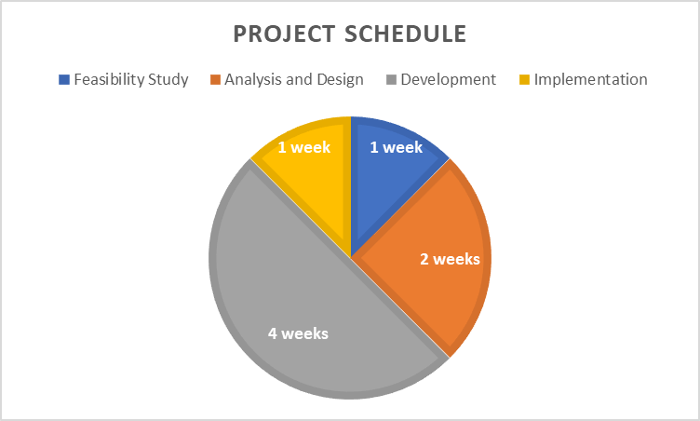
Figure 1: Project Schedule

CHAPTER 2 LITERATURE REVIEW

2.1 Introduction
Traditionally, the search for employment vacancies have been conducted in a tiresome way that for one to get employment they would be obligated to physically move around in search for employers with openings. The scenario was not any different for employers who are in need for individuals with a certain skillset. However, the wide distribution of computers, mobile phones, and communication technologies has made the whole process much simpler. Since the arrival of mobile phones in the 1980s, they have been widely used by people of all ages all around the world (Arceneaux, 2005). It could be said that the whole world is becoming mobile; mobile phones and personal computers are not only communication devices but also portable and private pieces of technological equipment. Nowadays, mobile technologies are becoming increasingly networked. Such technologies can be used creatively in different areas. Using mobile technologies in organizations like industrial institutions is a clear example of such an innovation. Laptops, Personal Computers, and even mobile phones equipped with internet connection have created the need for digitizing services such as job applications and even conducting businesses. Internet-enabled communication devices can help people from all walks of life can have the opportunity to access resources and services anytime, anywhere as long as they have an internet connection.

2.2 The Scope of Review
At the university level, students need access to internet-available resources in a fast and convenient way. This is very fundamental in not only the development of their skills and class performance but also aims to bring the university services right into their devices. Having the services accessible via internet is a good practice. In addition, for the students in the faculty of Computing and Informatics in any institution, they should be able to understand the advancement of technological trends and their effects and come up with solutions for the existing problems employing the best algorithms that address the issues at hand. Thus, having a website application that fetches resources, processes them, and generates the output to both the students and involved staff in a more efficient way is good to them.

2.3 Criteria Used
This literature review will be based on research about systems previously done, and which are related to this proposed system. The major focus will be on web-based applications that assist people apply for job opportunities online. Several web-based job application systems will be reviewed and investigated on how they have assisted people in the application and employment processes. All the data collected about the various web-based applications will be analysed and based on the analysis, the proposed system will be proved feasible or infeasible.
With the above at hand, existing literature will be subjected to investigation on web-based job application programs. The key concepts of the applications outlined, major relationships or patterns noted, key strengths and weaknesses identified and the research gaps will be outlined. The paper ends with a summary of agreements and disagreements in the literature, areas for further research, and the overall perspective.

2.4 Historical Background
Many web-based applications have been developed for mobile platforms. Over the last few years, these applications have been the focus not only of technical interests, but also marketing and business campaigns.
Recently, many researchers have focused on mobile and web technologies. This literature review will be based on research about the systems previously done, and which are related to this proposed system. The major focus on the same will be on job applications which are already in existence whereby each of their strengths and weaknesses will be determined. The online job application system is a web-based application that can be accessed using mobile phones, laptops, desktop computers or generally any internet enabled device with the capabilities to surf through the web. The difference between the online job application system and the current job application system is that the online job application system can be accessed anywhere at any time as long as you have internet connection while the current one entails physically submitting the forms to the respective offices.

2.5 Approaches
Approaches towards this review will be based on the web-based application systems that assist people in making their various applications processes online such as job applications. Therefore, the functionality of these websites will be determined and their strengths and weaknesses evaluated.
To achieve this, both a questionnaire and an interview research methodology will be used to clarify the research inquiry and if the inquiry is imperative or not.

2.6 Previous Studies
The existing systems enables jobseekers to search through print media like poster advertisements, newspapers and visual media like television or company websites for employment opportunities. This is a tedious task as it takes a lot of time and energy to search for the right job position, learn about the position and about the company. Job search for proper match of skill set and salary is challenging. Job seekers can also find jobs through job fairs where they must first make it possible to attend the fairs which might be sometimes impossible with their schedules and if they visit the fairs, they must hand over paper printed resumes. The more the number of candidates the more the number of papers for the company which is a lot of manual effort. Again, jobseekers might get job offers through placement cells in respective colleges but getting hold of the right opportunity at the right time is always challenging. On the other hand, the same goes for employers who are looking for candidates who are best fitted for their job positions. They must constantly advertise, go to a lot of job fairs which still doesn’t guarantee the best way to select from a large pool of candidates. Such conventional and outdated systems are replaced by several well featured national job search portals like MyjobsInKenya Online job application etc. All these job search and advertisement portals aims at e-recruitment by providing several simple and useful features to jobseekers and employers making job search and candidate selection a much time saving and easier process.

2.7 General Conclusions
After analysis of the review was done, the findings were that there is not yet any website that can solve the problem existing in the now available job application systems fully. Therefore, there will be the need for a system that will assist all members of the society to have a convenient and transparent job application process.

2.8 Conclusions
In conclusion, the above literature review shows that there are efforts to assist the jobless yet skilled people to have a convenient and transparent job application systems in place. Some have even gone an extra mile of providing a platform where the involved parties can contact the support team in case of any issue. Unfortunately, most of these platforms do not offer direct communication between the employer and those seeking employment.
Having such a platform would bring about convenience and transparency in the job application process. This would bring about the best user experience with the system due to the user friendliness.
As a result, this literature review permits and qualifies the implementation of a job management system which will not only fill the existing gap but also improve the user experience with a more user-friendly, convenient, transparent and reliable system.

CHAPTER 3 RESEARCH METHODOLOGY

3.1 Introduction
Examining the variables related to Kenya job application System, the enhancement of technology in the world and the contribution of these variables to the improvement of learner achievement demands dynamic research that is definitely rooted in both qualitative and quantitative epistemologies. This is necessary to ensure respondents (Employers and Employees) who are involved in a study of this magnitude and complexity are not denied their subjective views on the phenomena being studied while the objectivity of the entire research enterprise is guaranteed. In line with this thinking, this study is based on mixed methods research approach which is explained in detail in the following sections.

3.2 Summary of the Research Process
After identification of the research problem or an area of interest, the researcher has to identify appropriate method(s) to approach the problem. In order to give direction to this study, the research process shown below was adopted. The research process provides a summary of the important issues that were taken into consideration and reviewed before undertaking the research. The different steps in the diagram serve as a basis from which to consider the following: the logical orientation of the researcher, the research approach implemented, suitable research approaches, the research time lines that are under review and the data collection methods engaged by the researcher.
FIGURE 3.1 Research Process Summary
PHASE 2
Theories and Assessment Tools

PHASE 3
Data
Gathering

PHASE 4
Data Analysis and Conclusions

PHASE 1
Literature Review

1. Historical Information
2. Industry Information
3. Review of the related studies
1. Theoretical foundation
2. Questionnaire based on the chosen model

1. Questionnaire distribution
2. Gathering of answered questionnaires
1. Analysis of job application systems
2.Recommendation for future works

3.3 Research Design
According to Durkheim (2006), research design is a strategic framework for action that serves as a bridge between research questions and the execution or implementation of the research. Helen (1993) also helps to define it as a blueprint or a plan specifically created to answer the research question and to control variance. According to Leedey (1997), research design is a plan for study, providing the overall framework for collecting data. Quantitative research, according to Van der Merwe (1996), is research aimed at testing theories, determining facts, demonstrating relationships between variables and predicting outcomes. Quantitative research uses methods from natural sciences that are designed to ensure objectivity, generalizability and reliability (Weinreich, 1996).
The techniques used in quantitative research include unsystematic selection of research participants from the study population in an unbiased manner, the standardized questionnaire or intervention they receive and statistical methods used to test predetermined hypotheses regarding the relationship between specific variables. The researcher in quantitative research, unlike in the qualitative model where he/she is regarded as a great research instrument due to his/her active participation in the research process, is considered as being external to the actual research, and the results are expected to be replicable, no matter who conducts the research. Qualitative research intends to address questions concerned with developing an understanding of the meaning and experience dimensions of humans’ lives and social worlds (Fossey, 2002). Aspers and Corte define qualitative analysis as an interactive process which achieves improved understanding to the scientific community by making new significant distinctions resulting from getting closer to the phenomenon studied (Aspers & Corte, 2019).

3.4 System Requirement Gathering and Analysis

3.4.1 Requirement Gathering: Data Collection
This is a mixed methods research where both qualitative and quantitative methods of data collection were used to study the variables related to Kenya Education System and the enhancement of the technology in the world and the contribution of these variables to the improvement. Given this focus, questionnaires and interviews were used to collect data. According to Van der Merwe (van der Merwe, 1996), in theoretical studies, the researcher produces his/her evidence to support arguments from existing facts or information.

Questionnaires
A questionnaire is a form containing a set of questions, especially addressed to a statistically significant number of subjects. It is also a way of gathering information for a survey. It is used to collect statistical information or opinions about people. According to The Oxford Advanced Learner’s Dictionary (Mitton, 1992), a questionnaire is either a written or printed list of questions to be answered by a number of people, especially as part of a review. For the purpose of this study, the questionnaire was used as the first data collection method. The questionnaire was administered to 100 people from different areas in the country.

3.4.1.1 Construction and the Structure of the Questionnaires
Structured questionnaires were used as research instruments for the first section of this study. Two different questionnaires were constructed, one for potential employees and another one for different potential employers. The purpose of the questionnaire for potential employees was to find out how they apply for jobs available in the market and their insight in respect to the role of technology in the employment sector. On the other hand, the purpose of the questionnaire for the potential employers was to gather information concerning their perception with regard to the role of technology in the job application process and how they are able to get employees from the wide variety of applicants.

3.4.1.2 Distribution and Collection of the Questionnaires
The questionnaires, once drafted, were to be printed and then distributed to several areas around the country. Once delivered, specific people who were given mandate over a certain area were to source for volunteers from their areas who will then walk around the community issuing out the questioners to random people in the community and several employers in the community. The questioners are to be filled within a maximum time period of three days after which the volunteers will go around collecting the questioners from the community members and take them to the people in charge of the area who will then return them to the head office.
The head office will review the answers given which will give an insight on the view of the general public about the available job application system.

3.5 User Requirements Modelling

3.5.1 Use Case Modelling
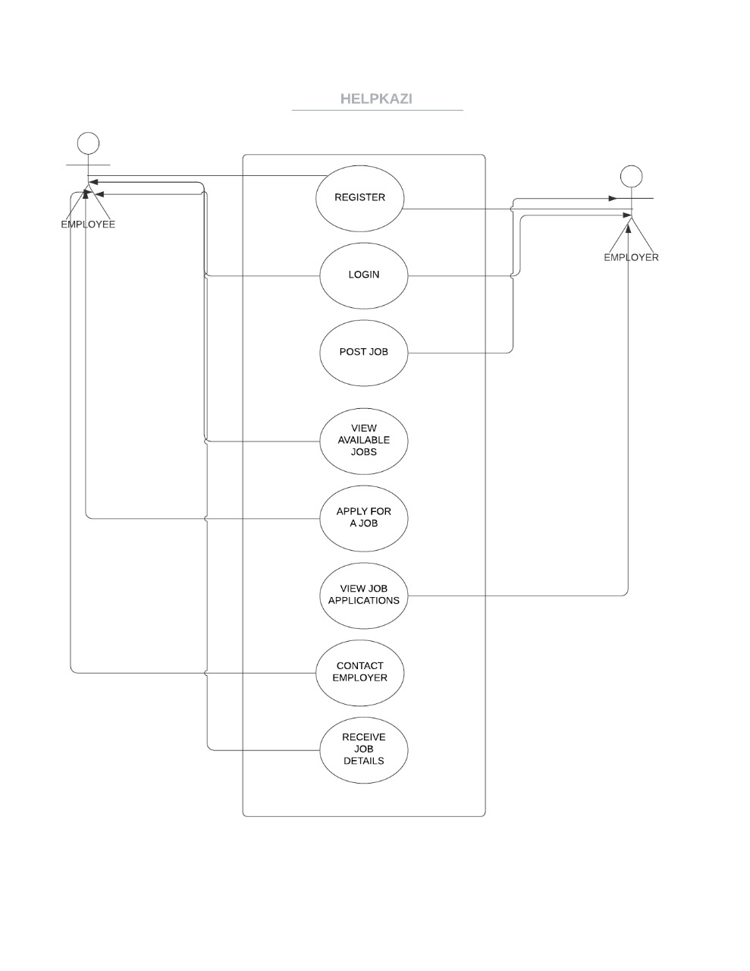
Figure 2 Use case diagram.

3.5.2 Activity Diagram
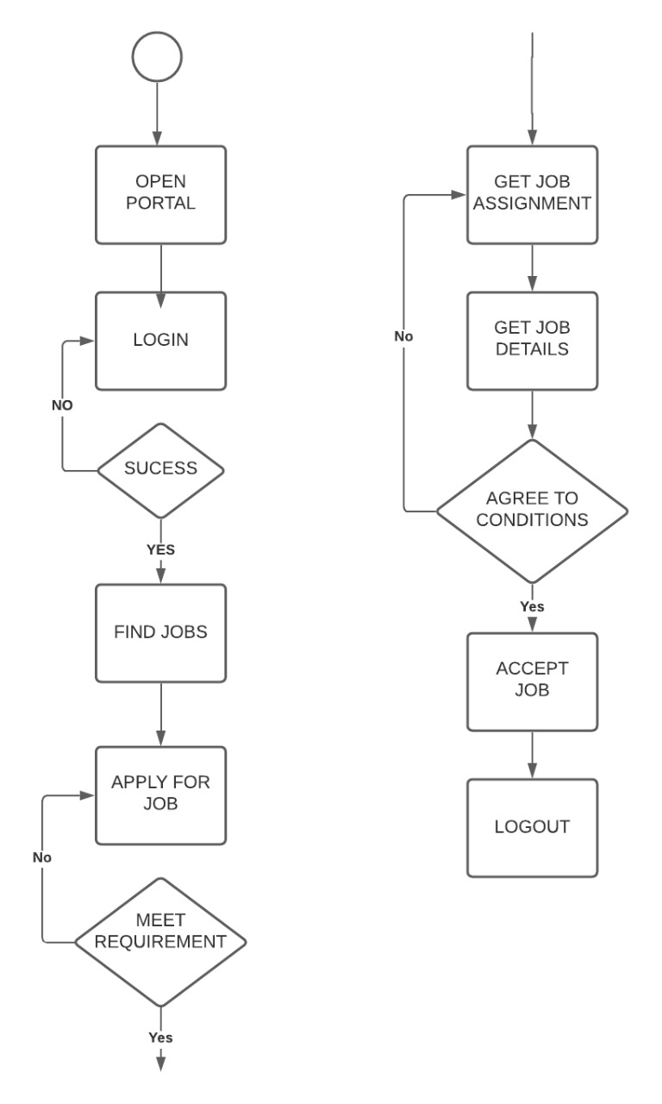

Figure 3. Client’s activity diagram.

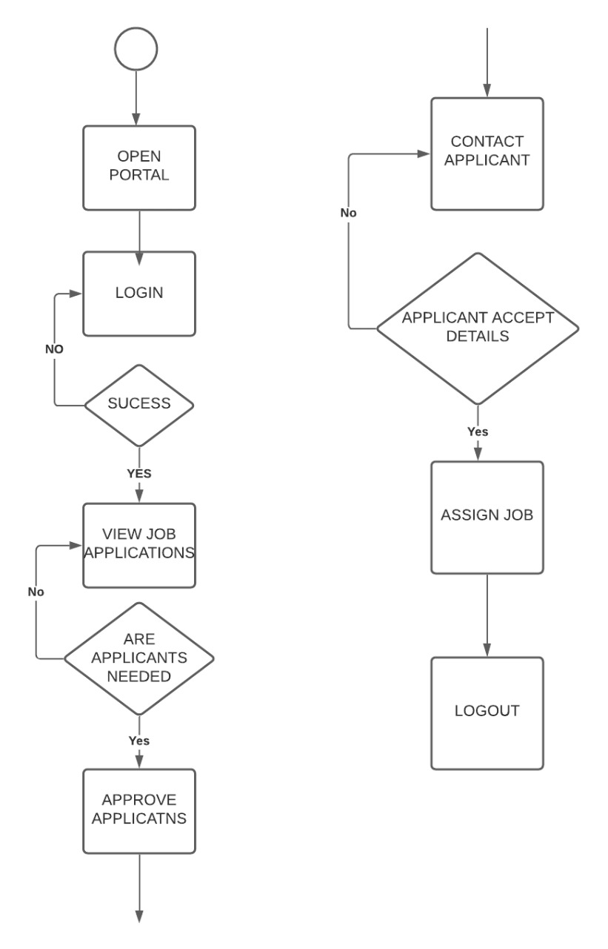

Figure 4.Employer’s activity diagram

3.5.3 Database Design

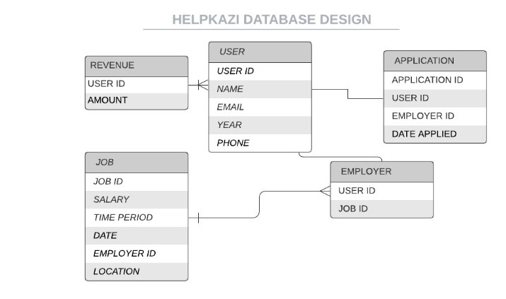

Figure 5.Help-Kazi database design

CHAPTER 4: SYSTEM DEVELOPMENT AND IMPLEMENTATION

4.1 Development Environment: Hardware Components
For the development of the Help-Kazi platform, some hardware components must be used to realize the final system. These system devices include:
Laptop brand: Dell Ultrabook
Processor: Intel(R) Core™ i5-4310U CPU @ 2.00GHz 2.60GHz
Hard Disk: 256 SSD

RAM: 8GB RAM

4.2 Development Environment: Software Components
The following are the system software used to come up with the entire system of Help-Kazi:

Windows operating system
Acts as the interface between the user and hardware. Basically, where all the software components run.
Version: Windows 10 pro

Visual Studio Code editor
A widely used code editor developed by Microsoft for writing, testing, debugging and implementing code snippets. It contains completion tools, compilers and other features to facilitate the software development process. Visual studio can be used in Windows, Linux and Mac Os or any other operating system.

MongoDB
The Help-Kazi platform uses the MongoDB which is a type of NOSQL Database that uses JSON documents to build highly available and scalable internet applications.

Heroku Hosting Platform
Heroku is a cloud platform as a service (PaaS) supporting several programming languages providing free deployment, of scalable and manageable application. One of the first cloud platforms, Heroku has been in development since June 2007.

Node.js
The Help-Kazi basically runs on node which is a JavaScript backend language that is used in sever-side rendering of the dynamic website, before the page is sent to the user’s web browser.

4.3 System Testing and Evaluation
In this phase the system components are reviewed and compared with the user requirements and specifications. Also bugs and system errors are fixed in this stage to ensure full functionality of the system.
The results are then evaluated to assess progress of design, performance and supportability of the system. The system will incorporate different levels of testing’s:
- Unit testing
- Integration testing
- System testing
- User acceptance testing

4.4 Unit Testing
The set of individual modules, control data and system procedures are tested to determine system fitness for use and if there are any bugs to be solved.
There are several modules that will undergo testing.

Employee (Job seeker)
For the employee, the following procedures will be examined for testing.
- Registration into the system
- logging into and out of the system
- Job application
- Viewing of available Job vacancies.
- Account details

Employer
The functions and procedures under test in this category are slightly similar to the employee’s details with a slight variation.
- Registration into the system
- Logging in and out.
- Posting of job vacancies
- Viewing of the applied job vacancies
- Account details

This units will be tested individually to identify any error or bugs that may need to be fixed before actual implementation of the system.

4.5 Integration Testing
Having tested each unit individually, the integration testing process proceeds.
In this phase, components of the subsystem are tested and combined into one system to ensure that the subsystem function together as a system.
The subsystem should interact with other subsystems of the entire system to perform the desired task. If bugs exist in this phase they are fixed before proceeding to the next phase.

4.6 System Testing
In this phase, the entire system is tested. This includes incorporation of all the system procedures, sub-modules and basic functionalities of the system.
The purpose of this phase is to determine how the user will feel and interact with the system and determine bugs that where not captured in the other phases.

4.7 User Testing
Several users will test and interact with the system to give back informative Feedback on the user friendliness and usability of the system. The feedback given by the end user will be used to improve the system further to meet the full user’s specifications and requirements.

CHAPTER 5: CONCLUSION
E-recruitment is one of the major advancements of the job industry today. Overcoming traditional methods of recruitment, e -recruitment has bought a revolutionary change in the world of interviews and recruitment. While this application aims in giving a user-friendly experience to the users with a simple but logical frontend it has achieved so at its completion. This application also achieves certain functional capabilities with the latest technology stack used in the industries today. The testing results shows that the application is scalable and can handle decent load. Also, this application does not have any geographical constraints as anyone from any part of the world can get registered to the application and search for jobs or post jobs.
Developing this project with a primary goal of learning new technologies, we have achieved immense exposure in understanding technologies like NodeJS not only at the implementation level but also in understanding the background of such technologies. Similarly, we have also learnt AngularJS and have witnessed how powerful front-end tool can be to make your life a lot easier with front end developments. Some of the major challenges faced was in understanding the call back concepts and implementing them in the application. To debug, test and run the application we have encountered many cutting-edge technologies and learnt about them. This invariably have enhanced our hands-on knowledge with a broad spectrum of technologies which would come handy once we start facing the industry after our graduation.

5.1 Shortcomings of the System

After our initial UI construction, we have found that we needed to add some additional capabilities. The primary one was to optimize the search space for which we have developed an advanced search feature. Another evolvement of my UI was adding pagination to handle a lot of data. We have tested my application on other computers with different software specifications and found significant differences in load testing.

5.2 Recommendation for Future Work
There is ample scope of enhancement and adding functionalities to this application. This application can be extended to send automated interview scheduling through acceptance/rejection of resume. Companies can delete jobs once the job availably period is over automatically. The application can have a job recommendation system based on the frequent search results of different users. The portal can also send email notifications to candidates about certain job availabilities. There can be a feedback or review section for the application. Also, unlike the current job description page, user can view job description in a separate page with one click on the job description. The user functionality can be extended to give the user options to save the job and later apply, to upload multiple documents. The application can be more scalable by extending the search functionality based on country, city or area. While this application meets the basic requirements of a job portal eliminating few of the traditional challenges faced like time, money and effort, it can be extended to make the application more dynamic and robust. The User Interface can be made more attractive and user friendly. We can dig through more AngularJS magic capabilities to add additional features to the UI.

REFERENCES
Arceneaux, N. (2005). The world is a phone booth:. The American response to mobile phones, 1981-2000.
Leedy, P. D., & Ormrod, J. E. (1997). Practical research (Vol. 108). Saddle River, NJ: Pearson Custom.
Van der Merwe, H. (1996). Delivering justice during transition: Research challenges. Assessing the impact of transitional justice: Challenges for empirical research, 115, 115.
Mugenda, O. M., & Mugenda, A. G. (2003). Research Methods: Sample size determination. African Centre for Technology Studies.
Fossey, E., Harvey, C., McDermott, F., & Davidson, L. (2002). Understanding and evaluating qualitative research. Australian & New Zealand Journal of Psychiatry, 36(6), 717-732.
Durrheim, K. (2006). Research design. Research in practice: Applied methods for the social sciences, 2, 33-59.
Dulock, H. L. (1993). Research design: Descriptive research. Journal of Paediatric Oncology Nursing, 10(4), 154-157.
Weinreich, N. K. (1996). A more perfect union: Integrating quantitative and qualitative methods in social marketing research. Social Marketing Quarterly, 3(1), 53-58.
Aspers, P., & Corte, U. (2019). What is qualitative in qualitative research. Qualitative sociology, 42(2), 139-160.
Mitton, R. (1992). A description of a computer-usable dictionary file based on the Oxford Advanced Learner’s Dictionary of Current English. Available online (and accessed 07/03/08) from: http://coral. lili. uni-bielefeld. de/Classes/Winter98/ExP hon/SynthDBNotes/synthdbnotes/node18. html.

APPENDIX 1:

APPENDIX 2:

